Transformer overheat control system & intimation to EB
The Transformers used in EB are mainly to handle the high power ratings, hence it dissipate more heat. When the temperature goes beyond certain limit, it may burst and may hurt the people closer to it. This also causes remarkable loss and threatening human life. This project is developed to protect such incidents, by monitoring the temperature of the transformer and controlling the heat. When the heat is not under the control, it may alert the EB department to take action.

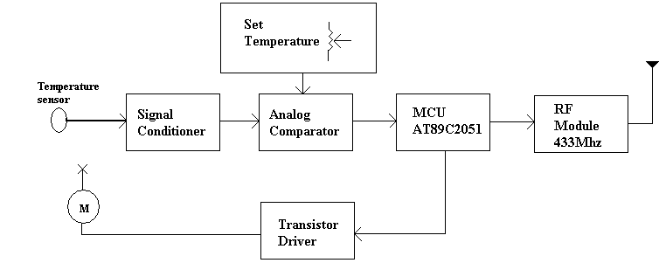

System Installed in Transformer

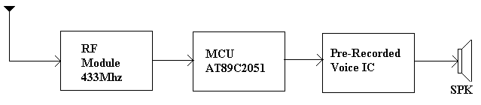
Enunciator installed in EB office

A temperature sensor is fixed on the body of the transformer, which is to be monitored (Refer first Block Diagram). The sensor produces weak current signal, proportional to the temperature. This current signal is amplified and converted as analog voltage signal by the signal conditioner. An analog comparator is used to compare this analog voltage with a pre-set input (Which is the set temperature). This comparator produces trigger logic ‘1’, when the temperature of the transformer exceeds the threshold value. The trigger signal is fed as input to a microcontroller port pin. The microcontroller senses this logic’1’ signal and switch ON the cooling fan waits for few minutes. If the temperature is not become low with in this period, then the controller sends alert code with its identification code to a RF module. The RF module is gets the data from microcontroller, modulates the digital signal with 433Mhz carrier and transmits. The module uses Amplitude Shift Keying (ASK) type modulation technique.

Enunciation Block
The RF signal transmitted is received by a RF receiver module. This module is tuned to 433Mhz and demodulates the carrier and reproduces the digital data. This data is fed to a microcontroller (AT89C2051). The microcontroller gets the data and identifies the transformer ID and alert code. The microcontroller enables the Voice IC to play a pre-recorded voice message.

The application program for the microcontroller will be written in embedded ‘C’ and will be stored in the flash memory of the microcontroller.

