Power Line monitoring system using embedded controller
The main objective of this project is to share the 3 Phase supply efficiently. This also monitors the supply voltage level. If the supply voltage is not within the set limit (i.e. Over voltage or Under Voltage), the other phase, which is in limit is utilized.

Each phase is connected to a voltage sensing circuitry. The voltage sensing block sends dc analog signal, which will be in the range of 0-5V for the line voltage of 0-230V AC. These analog signals are connected to an ADC (Analog to Digital Converter). The ADC converts the data in to discrete form and sends binary data to the microcontroller. The microcontroller takes these data and controls the relays.
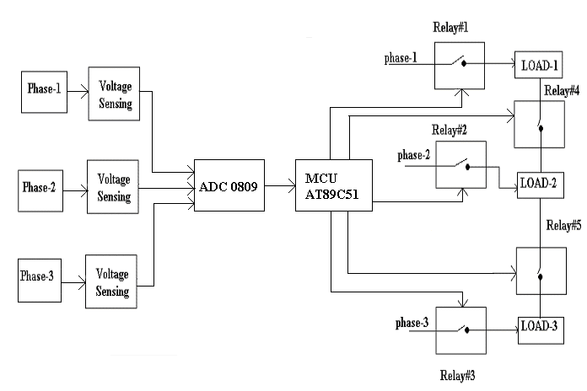
The voltage levels of all phases are monitored by the microcontroller. If the phase 1 fails or it is below the threshold, Relay#1 is switched off thus removing the Load1 from phase 1 and connects the load to the phase2 by switching ON the Relay 4. Similarly the supply is monitored and shared.

The application program for the microcontroller will be written in embedded ‘C’ and will be stored in the flash memory of the microcontroller.

