Designing of I2C Master core using Verilog HDL

This project is aimed at designing of a Master controller for I2C bus using the Verilog Hardware Description Language (HDL). For a long time, programming languages such as C, Pascal & FORTRAN were being used to describe the computer programs that were sequential in nature. Similarly in the digital design field, designers felt the need for a standard language to describe digital circuits. Thus, HDL came into existence. HDL allowed the designers to model the concurrency of processes found in hardware elements.

I2C is a two-wire, bi-directional serial bus that provides a simple and efficient method of data exchange between devices. It is most suitable for applications requiring occasional communication over a short distance between many devices. The I2C standard is a true multi-master bus including collision detection and arbitration that prevents data corruption if two or more masters attempt to control the bus simultaneously. This core, however, supports only single master operations, in which the core is the master.

The I2C interface uses a serial data line (SDA) and a serial clock line (SCL) for data transfers. All devices connected to these two signals must have open drain or open collector outputs. Both lines must be pulled-up to VCC by external resistors.

I2C Protocol
Normally, a standard communication consists of four parts:
1) START signal generation
2) Slave address transfer
3) Data transfer
4) STOP signal generation

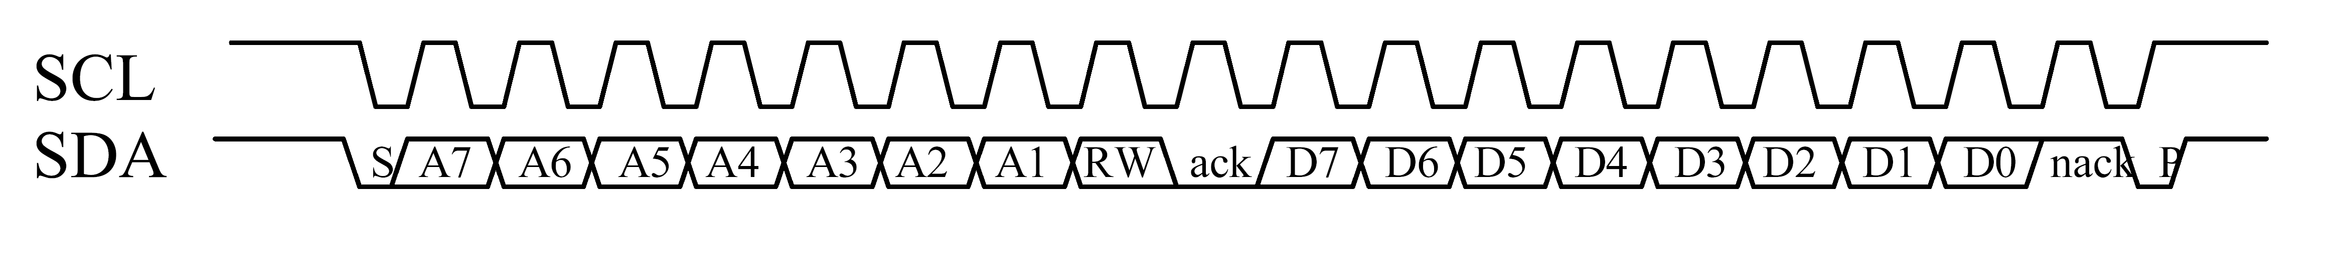

The designing steps of core are listed below.

- The functional description of I2C master has to be described in the Verilog HDL. That is called design module / core.
- The test bench program has to be developed to test the design module. The test bench gives the input to the design module & verifies the outputs. The test bench has to be written in such way to check the design module in all possible conditions.
- Verilog simulator tool is used to verify the design functioning. (Simulation).
- Protocol block of the design module shall be synthesized and the gate level netlist shall be generated.
- The generated gate level netlist file has to be converted as PLD (Programmable Logic Device) image file and has to be programmed in CPLD device.
- One hardware testjig will be wired & the CPLD functioning will be verified.

The use of Verilog HDL has many advantage compared to the traditional schematic based design.

- Designs can be described at very abstract level using HDL. Designers can write their design description without choosing any specific fabrication technology. If a new technology emerges, designers do not need to redesign their circuit. They simply input the design program to the logic synthesis tool and create a new gate level netlist using the new fabrication technology. The logic synthesis tool will optimize the circuit in area and timing for the new technology.
- By describing the design in HDL, functional verification of the design can be done early in the design cycle. Since designers work at the high level language, they can optimize and modify the design module until it meets the desired functionality. Most of the design bugs are eliminated at this point.

