Line Monitoring System using FPGA

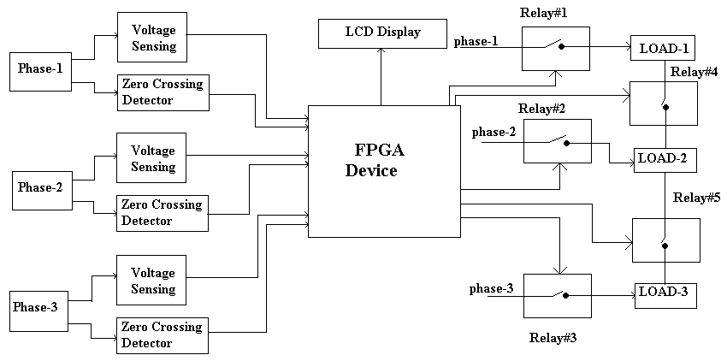
In this project, the three Phase supply is monitored and shared to loads using FPGA (Field Programmable Gate Array). Here the control logic is implemented in FPGA device. The presence of each phase is sensed by the voltage sensing circuitry. The Voltage sensing Circuitry sends ‘0’ logic to the FPGA, if the phase line is alive otherwise sends ‘1’ logic. The FPGA checks all the phase lines, if all the lines are alive, the Relays 1,2 & 3 will be ON state and Relay 4 & 5 will be in OFF state. Thus Phase1 is loaded with Load1 and Phase 2 is loaded by Load2 and so on. Thus each phase is equally loaded, when all the phase lines are present.

On Phase 1 failure condition, Relay 1 is Switched OFF and Relay 4 is switched ON. So that the phase2 derives Load1 & Load2. When phase 2 fails, the Relay 2 is switched OFF and Relay4 is switched ON to Share the load with Phase1. Similarly when Phase 3 fails, the Relay3 is switched OFF and Relay 5 is switched ON. When any two phases fails, the other single phase, which is alive will be deriving all the loads till the failed phases to restore.

The Line Frequency of all phases are monitored with the help of zero crossing detector and displayed in the LCD. The Zero Crossing Detector sends pulse to the FPGA, for every zero crossing of phase line. The FPGA calculates timing between the pulses to find the frequency of the phases.

The controlling program is written in Verilog HDL (Hadware Description Language) and synthesized using Xilinx Webpack Software to get the configuration file for FPGA. The configuration file is programmed to platform PROM of FPGA, which is also loaded to the FPGA. Thus FPGA internal logics are get configured and senses the input signals and controls the relay and LCD signals.

Usually the FPGA has internal configuration RAM, which losses its configuration, when the power fails. To avoid such problems, the board is designed with platform PROM (which is non-volatile memory), which loads the content to FPGA RAM on power up.

